Experience AI Lessons

Unit introduction
Welcome to our series of six lessons that will give your students an introduction to the world of artificial intelligence (AI) and machine learning (ML). Throughout this unit, your students will experience a variety of real-world AI applications and be made aware of the ever-increasing range of AI-related careers. As well as considering the social and ethical implications of AI developments, you and your students will have the opportunity to delve deeper and explore machine learning models and the engines that make them work. Your students will be able to take part in practical activities, in which they will create their own machine learning models using the free web-based tool Machine Learning for Kids and take a project from start to finish by going through the stages of the AI project lifecycle.

Overview of lessons
Lesson | Brief overview | Learning objectives
1 – What is AI? | In this lesson, students will explore the current state of artificial intelligence (AI) and how it is used in the world around them. They will consider some of the benefits and drawbacks of AI systems.  First, students will think about the term ‘intelligence’ and take part in a game of noughts and crosses (tic-tac-toe) against an algorithm (‘the intelligent piece of paper’). Students will then be introduced to artificial intelligence and examine the difference between rule-based and data-driven approaches, before being given time to explore two AI applications. Students will be asked to consider the benefits that each application could bring to society, as well as to think about any negative consequences that their use could lead to. | - Describe the difference between ‘data-driven’ and ‘rule-based’ approaches to application development  - Name examples of AI applications  - Outline some benefits and issues of using AI applications
2 – How computers learn from data | In this lesson, students will build on the new view of artificial intelligence from Lesson 1, with a particular focus on the use of data in AI systems. The activities will help students think critically about which parts of a system use AI principles, and the role machine learning plays in creating the models introduced in Lesson 1.  First, students will consider the functionality of a ‘smart’ speaker, with the aim of identifying which uses involve data-driven techniques and which do not. Next, they will be introduced to the definition and description of ‘machine learning’ and its role in the landscape of AI. Students will hear from experts about the different types of machine learning and the problems its use can help solve.  Finally, students will learn about a specific example of machine learning — classification. This is where algorithms are used to classify (group) data into categories (called ‘classes’), and example data that has already been labelled must be used to train the algorithms. | - Define machine learning’s relationship to artificial intelligence  - Name the three common approaches to machine learning  - Describe how classification can be solved using supervised learning
3 – Bias in, bias out | In this lesson, students will have an opportunity to create their own machine learning model. The model will classify images of healthy and unhealthy cassava plants but students will discover that their model is flawed due to the limited data set they will use to train their models. Next, students will explore how bias can appear in sets of data used to train models, which in turn make the models produce biased predictions. | - Describe the impact of data on the accuracy of a machine learning (ML) model  - Explain the need for both training and test data  - Explain how bias can influence the predictions generated by an ML model
4 – Decision trees | In this lesson, students will take their first in-depth look at a type of model: decision trees. The activities build on students’ learning from Lessons 1–3 about classification, training and test data, and the data-driven nature of models. The aim of this lesson is for students to gain an understanding of the processes used to create machine learning models.  First, students will learn about the structure of a decision tree, introducing them to the key terminology and parts of a decision tree. Then, they will see how a decision tree is used to process data and predict a label.  Next, students will see how a decision tree is made using training data. You will demonstrate the process for them using the slide deck, then they will apply the process independently with new training data. Students will also have an opportunity to see what the term ‘data-driven’ really means, as the two decision trees that they create with separate training data will be different.  Finally, students will explore the reasons machine learning is useful when creating decision trees, with regard to both scale (data sets used to create ML models are very large) and adaptability (being data-driven). They will use Machine Learning for Kids to create a decision tree using a larger set of data, and will use the decision tree that they create. | - Describe how decision trees are used to build a classification ML model  - Describe how training data changes an ML model  - Explain why ML is used to create decision trees
5 – Solving problems with ML models | In this lesson, students will be introduced to the AI project lifecycle and use it to create a machine learning model to solve a problem of their choice.  First, students will order the stages of the AI project lifecycle. They will then be introduced to the idea of needing to take a user-focused approach when working on AI projects. Students will be presented with a choice of projects to select from, then they will be asked to train a machine learning model and test it to determine its accuracy. | - Describe the stages of the AI project lifecycle  - Use a machine learning tool to import data and train a model  - Test and examine the accuracy of an ML model
6 – Model cards and careers | In this lesson, students will complete the final stages of the AI project lifecycle: evaluating and explaining a model. To help them explain their model, students will be introduced to model cards, which are a way for the developers of a model to share important information about how to use the model, the results of testing, and any limitations relating to the accuracy of the model.  In the final activities in this lesson, students will explore a range of careers both in the field of AI and in other fields in which AI applications are used. Students will learn more about the staff members at DeepMind who have featured in the videos they have watched throughout the unit, as well as exploring how AI applications and machine learning can be used in fields they are interested in. | - Evaluate an ML model  - Produce a model card to explain an ML model  - Recognise the range of opportunities that exist in AI-related careers

Assessment
Opportunities for formative assessment are outlined in the lesson plan for each of the six lessons. In addition, this unit includes a summative assessment consisting of 19 questions. The document includes the assessment as well as the answers, and has been designed to support you to be able to quickly assess the progress made by your students and help identify where any gaps have formed in their learning of this topic. We have also designed the questions to make them suitable for uploading to online self-marking platforms such as Google Forms.

Progression
Progression for this unit has been carefully considered with regard to how students might progress through the AI concepts included in the lessons. Learning graphs have been produced to demonstrate this progression. In order to learn some of the concepts and skills, students need prior knowledge of others, so the learning graphs show how the concepts and skills are related. The learning graphs are designed for use by teachers.

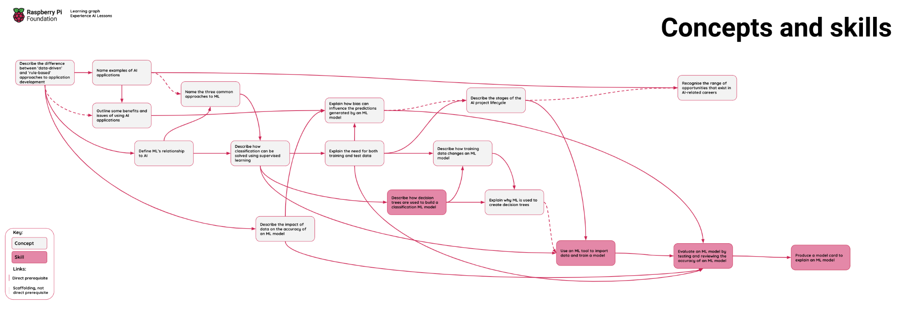

The learning graphs have been provided in three formats to demonstrate how learning progresses against three measures:

- Concepts and skills
- The SEAME framework (rpf.io/seame)
- Bloom’s Taxonomy (rpf.io/blooms)

Subject knowledge
This unit has been designed to support teachers who may be new to delivering AI and ML content to young learners. The lesson plans include detailed explanations of all of the key vocabulary and concepts covered in each lesson, and the slide decks include videos from the experts at DeepMind, who will describe new concepts directly to your students.

Evaluation — schools in the UK
A team at the University of Cambridge is conducting surveys to evaluate the experiences of teachers and students using this unit of lessons. The surveys are open to students aged 11–14 and their teachers, at schools in the UK.

By taking part in the surveys, you and your students can help shape the future of AI education. You will also have the chance to opt in to a prize draw to win £50 worth of book tokens for your school.

The surveys are designed to be completed at the start and end of the unit. The teacher surveys will take approximately 5 minutes to complete, while the student surveys will take approximately 10–15 minutes.

Start of the unit

Before you start Lesson 1, please use the following links to take part in the surveys:

- Start-of-unit teacher survey (rpf.io/teachstart)
- Start-of-unit student survey (rpf.io/studentstart)

End of the unit

After you have finished the unit, please also complete the end-of-unit surveys using the links below.
Note: Even if you or your students did not do the start-of-unit surveys before Lesson 1, you can still take part in the end-of-unit surveys.

- End-of-unit teacher survey (rpf.io/teachend)
- End-of-unit student survey (rpf.io/studentend)

This resource is licensed by the Raspberry Pi Foundation under a Creative Commons Attribution-NonCommercial-NoDerivatives 4.0 International Public License (CC BY-NC-ND 4.0). For more information on this licence, see creativecommons.org/licenses/by-nc-nd/4.0.

